1. Explain features of python
2. interactive: You can actually sit at a Python prompt and interact with the interpreter directly to write your programs.
3. Easy to learn and use: Python is easy to learn and use. It is developer-friendly and high level programming language.
4. Expressive language: Python language is more expressive means that it is more understandable and readable.
5. Interpreted language: Python is an interpreted language, ie., interpreter executes the code line by line at a time. This makes debugging easy and thus suitable for beginners.
6. Platform independent: Python can run equally on different platforms such as Windows, Linux, Unix and Macintosh etc. So, we can say that Python is a portable language.
7. Free and Open source: Python language is freely available at official web address. The source-code is also available. Therefore it is open source.
8. Object-Oriented language: Python supports object oriented language and concepts of classes and objects come into existence.
9. Large Standard Library: Python has a large and broad library and provides rich set of modules and functions for rapid application development.
10. GUI Programming Support: Graphical user interfaces can be developed using python.
11. Python also features dynamic type system and automatic memory management.
12. Extensible: It implies that other languages such as C/C++ can be used to compile the code and thus it can be used further in our python code.
13. Define
    1. Keywords :

* Keywords are reserve words which convey a special meaning to interprter.
* keywords can’t be used as identifiers or variables or function name.
* Eg: if ,else,elif,while,True,False,import (Total 33 keywords)
  1. Variable :
* Python variables are the reserved memory locations used to store values with in a Python Program.
* Variable names should have combination of lowercase(a to z) & uppercase(A to Z) letters or digits(0 to 9)or underscore(_).
  1. Comments
* Comments are statements that are ignored by interpretor in python program.

Comments

Single-line comment multi-line comment

Denotion : # Denotion : “”” “””

For single line comment used to provide detail explaination about code,block.

* 1. Indentation
* Indentation refers to spaces at the beginning of a code line.
* Python indentation is used to declare block of code.
* Incorrect indentation will create indentation error.

1. Explain any two data type in detail
   1. Tuple

* Tuple is a collection of objects which are immutable and ordered.
* Tuple is inbuilt data structure in python
* A tuple consist of number of values separated by commas & enclosed in ()
* Some inbuilt function used with tuple are :
  + Len() : return no. of elements in a tuple
  + max() : return maximum element in a tuple
  + min() : return minimum element in a tuple
  + sum() : return sum of all elements of a tuple
  + index(x) : return index of element x
  + count(x) : return number of occurences of element x
* Syntax : my_tuple=(item1,item2…..itemn)
* 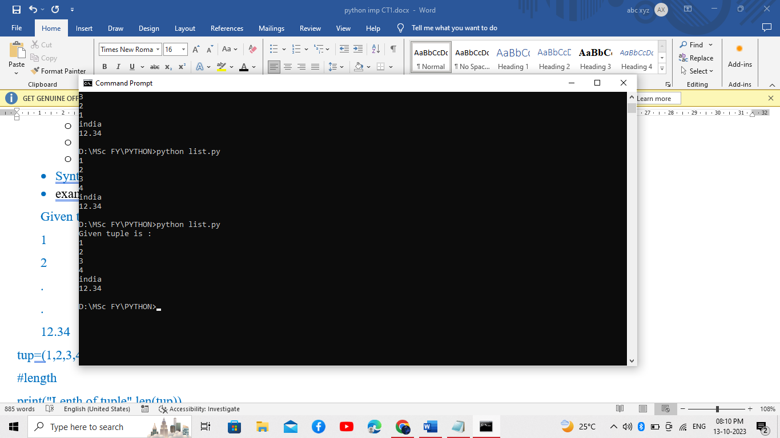example :

tup=(1,2,3,4,'india',12.34) o/p :

print("Given tuple is : ")

for i in range (len(tup)):

print(tup[i]

* 1. List
* A list is created by placing all the items (elements) inside square brackets [], separated by commas.
* List is mutable which mean We can update the list such as adding and removing elements during execution.
* A list is an object that contains multiple data items (elements).
* It can have any number of items and they may be of different types (integer, float, string etc.)
* Duplicate elements are also allowed into list.
* Syntax : my_list=[item1,item2…..itemn]
* 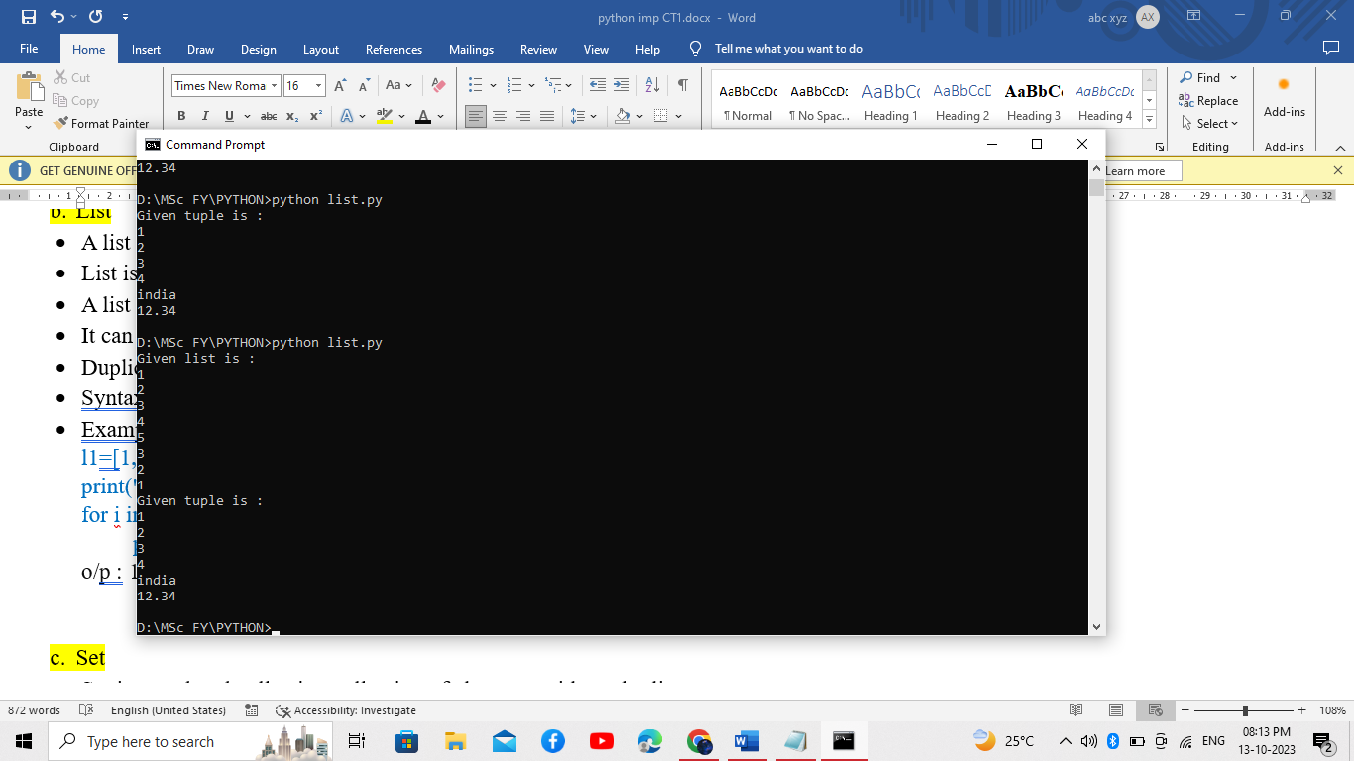Example :

l1=[1,2,3,4,5,3,2,1] o/p:

print("Given list is : ")

for i in range (len(l1)):

print(l1[i])

* 1. Set
* The set in python can be defined as an unordered collection of various items enclosed within the curly braces({ }).
* Set is unordered collection collection of elements without duplicates
* Sets are immutable
* The elements of the set cannot be duplicated and cannot be changed.
* There is no index allocated to the elements of the set, 1.e., we cannot directly access any element of the set by the index.
* We can print all the elements by looping through the set.
* Syntax : my_set={item1,item2…..itemn}
* Example :

s1 = {'Hello', 101, -2, 'Bye'}

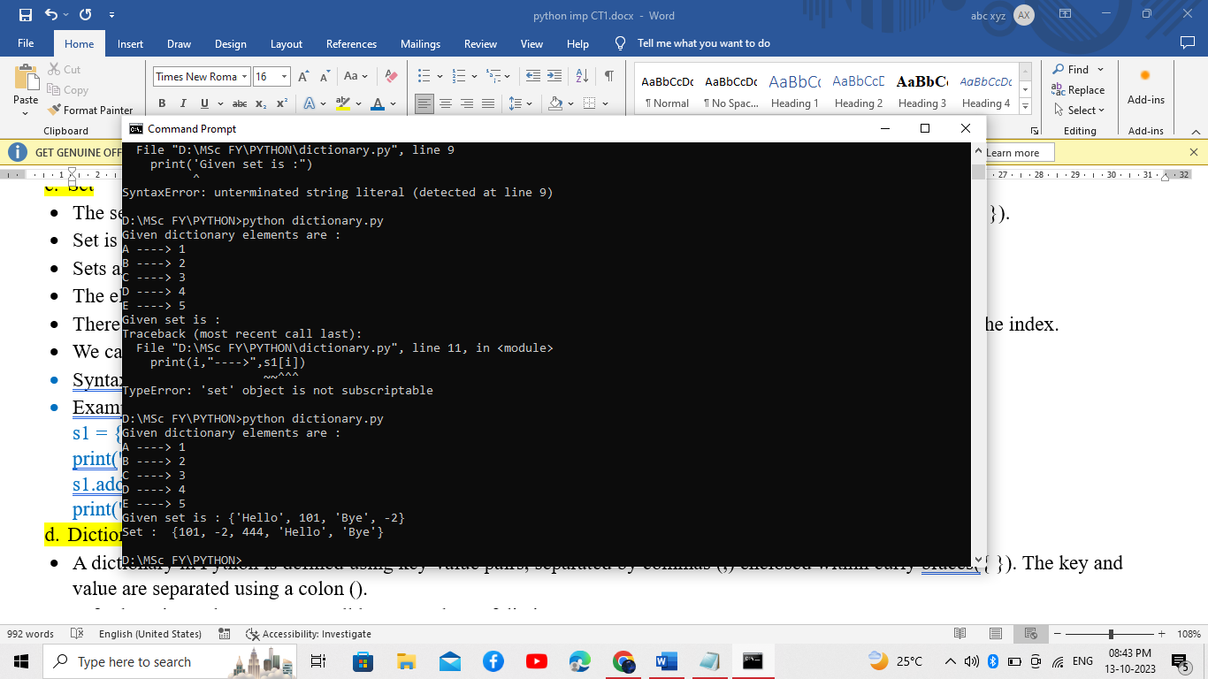print("Given set is :",s1)

s1.add(444)

print("Set : ",s1)

* 1. Dictionary

**A dictionary in**[**Python**](https://www.geeksforgeeks.org/python-programming-language/) is a collection of key values, used to store data values like a map, which, unlike other data types holds **Key-value** only a single value as an element.

* A dictionary in Python is defined using key-value pairs, separated by commas (,) enclosed within curly braces({ }). The key and value are separated using a colon (:).
* A for loop is used to transverse all keys & values of dictionary.
* The keys defined for a dictionary need to be unique, for keys.
* The values in a dictionary can be mutable
* Dictionary items are unordered, changeable, and does not allow duplicates.
* Syntax:

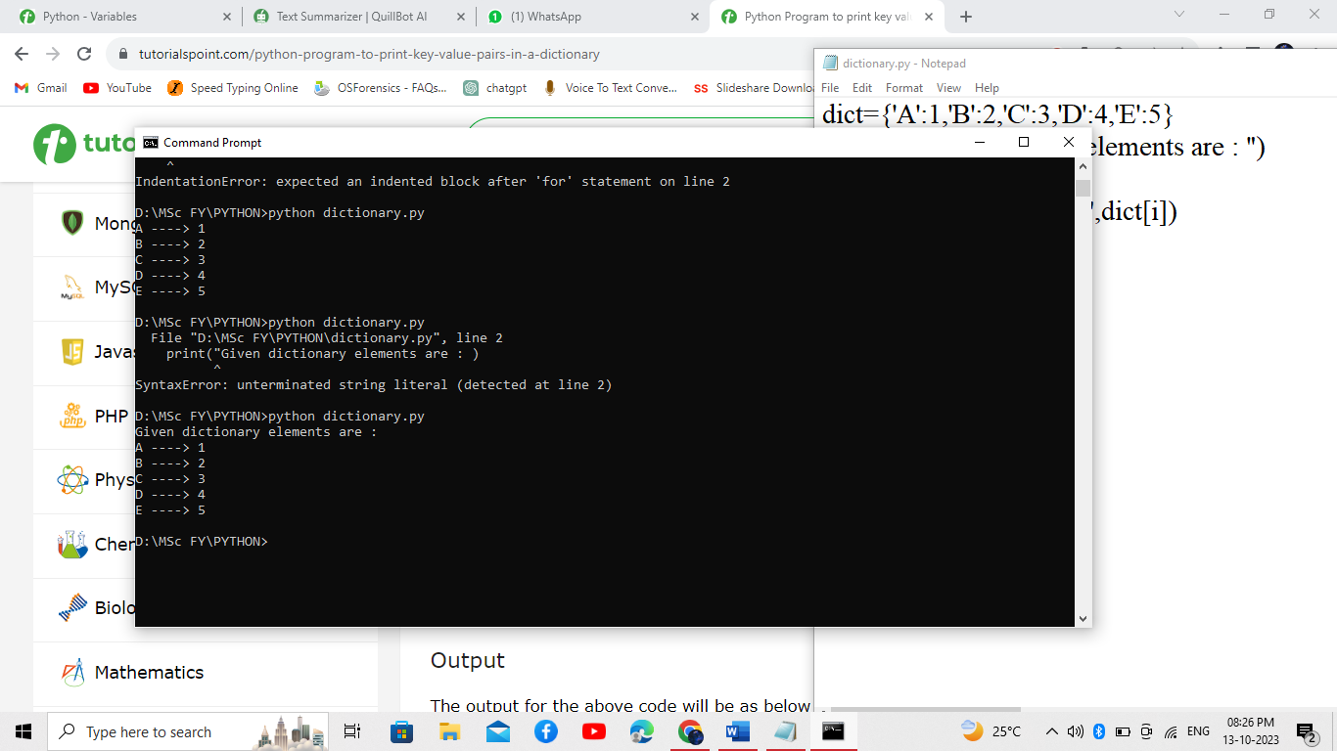mydict = {

"key1 ": "value1 ",

"key2 ": "value2 ",

……………..}

* Example :

dict={'A':1,'B':2,'C':3,'D':4,'E':5}

print("Given dictionary elements are : ")

for key in dict:

print(key,"---->",dict[key])

1. Explain operators in python

## 1. Python Arithmetic Operators

* Arithmetic operators are used to perform mathematical operations like addition, subtraction, multiplication, etc.
* + , - ,* , / , // ,** ,%

Example :

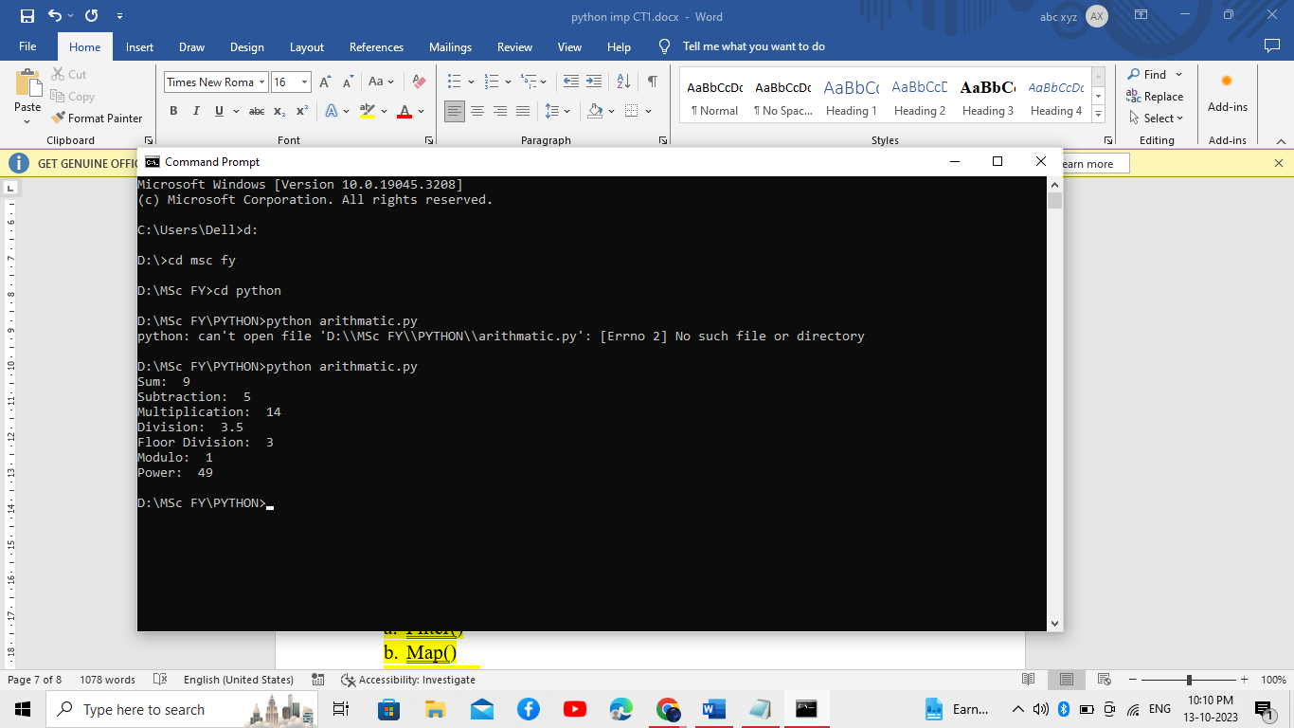a = 7

b = 2

print ('Sum: ', a + b)

print ('Subtraction: ', a - b)

## 2. Python Assignment Operators

* Assignment operators are used to assign values to variables.
* = , += ,-= , *= ,/+ , %= , //= ,**= ,&= ,>>= , <<=
* 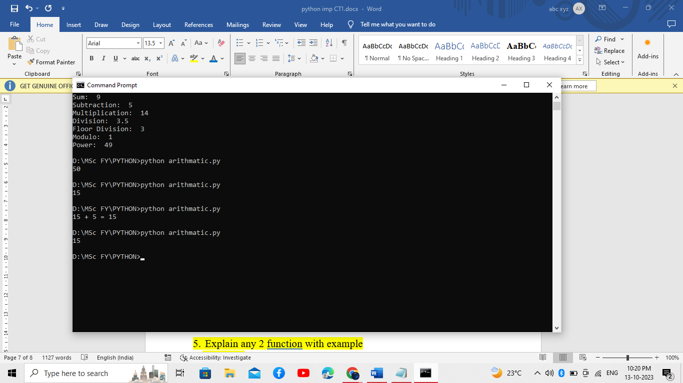For eg :

a = 10

b = 5

a += b # a = a + b

print(a)

## 3. Python Comparison Operators

* Comparison operators compare two values/variables and return a boolean result: True or False.
* == ,!= ,> , < .>= ,<=
* For eg :

a=23

b=34

print(a>b)

print(a<b)

o/p : False

True

4.Relational operator

>,<,<=,>=,==,!=

## **5. Python Logical Operators**

Logical operators are used to combine conditional statements

AND , OR , NOT

Example :

N1=2

N2=5

If(n1)

1. Explain any 2 function with example

Map, filter, and reduce are three special functions in Python that are used to process iterables. They are all built-in functions

* 1. Filter()
* The filter() function is utilized to apply a function to each element of an iterable (like a list or tuple) and return another iterable containing just the elements for which the function brings True back.
* ##The filter() function returns an iterator where the items are filtered through a function to test if the item is accepted or not.
* The filter() function creates a new iterator that filters elements from a previously created one (like a list, tuple, or dictionary).
* The filter() function’s time complexity= O (n)

## **Syntax :** filter(function, iterable)

import functools

def prime(n):

for i in range (2,n//2+1):

if(n%2==0):

return(False)

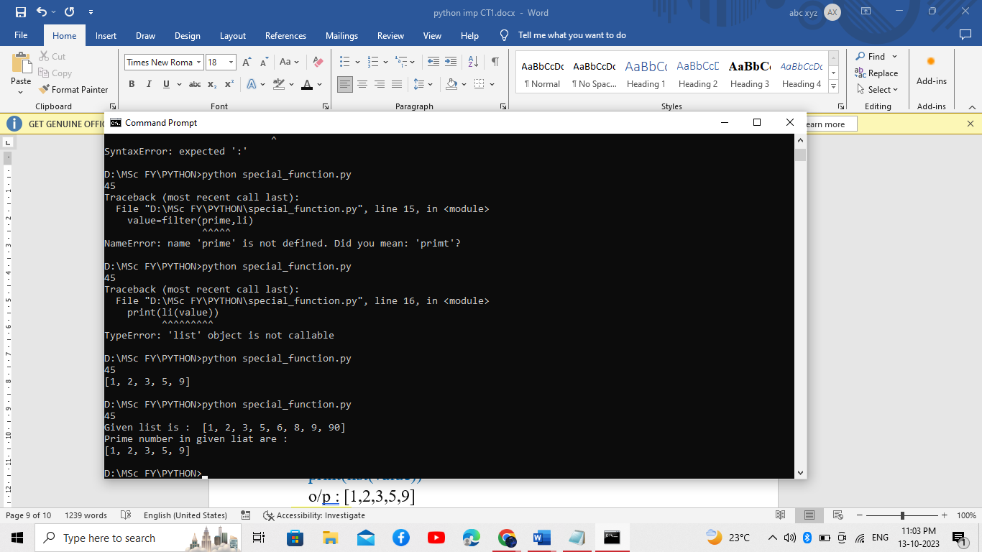 return(True)

li=[1,2,3,5,6,8,9,90]

value=filter(prime,li)

print("Given list is : ",li)

print("Prime number in given list are : ",list(value))

o/p : [1,2,3,5,9]

* 1. Map()
* The map function in Python is a built-in function that applies a given function to each element of an iterable (list, tuple etc.) and returns an iterator containing the results.
* the map() function can be used to perform mathematical operations on two or more lists. It can even be used to manipulate any type of array.
* The map() function executes a specified function for each item in an iterable. The item is sent to the function as a parameter.

## **Syntax :** map(function, iterable)

def fact(n):

f=1

for i in range (1,n+1):

f=f*i

return f

li=[1,2,3,4,5]

res=map(fact,li)

print(list(res))

o/p : [1,2,6,24,120]

* 1. Reduce()
* Reduce fn is used to apply a fn to all the element of a sequence.
* We have to import package functools for this function. As It is in the functools library.
* the reduce() function iterates through each item in a list or other iterable data type, returning a single value. This is more efficient than looping.
* Syntax : functools.reduce(function,sequence)
* Example :

from functools import reduce

def fun(a,b):

return(a+b)

li=[1,2,3,4,5,6,7,8,9]

res=reduce(fun,li)

print(res)

o/p : 45

1. Explain any two array operation with example
   1. Traverse

* Traversing an array means visiting each element of the array in a specific order. The most common way to traverse an array is using a for loop
* For example, the following code traverses an array and prints each element to the console:

my_array = [1, 2, 3, 4, 5]

for element in my_array:

print(element)

o/p : 1,2,…5

* 1. Insertion :- NOTEBOOK
* Inserting an element into an array means adding the element to the array at a specific position.
* To insert an element into an array, you can use the insert() method.
* The insert() method takes two arguments: the index at which to insert the element and the element to insert
  1. Deletion :- NOTEBOOK
  2. Search

import array

arr=array.array("i",[1,2,3,4,5,6])

for i in arr:

print(i,end=" ")

print("\n")

print("which number you want to search:")

n=int(input())

f=0

for i in range(0,len(arr)):

if(arr[i]==n):

print("Number is found at position",arr.index(arr[i]))

f=1

break

if(f==0):

print("Number is not found")

* 1. Update

You can update elements in an array by accessing the element using its index and assigning it a new value.

import array as arr

a=arr.array("i",[1,2,3,4,5,7,8])

print("Array before updation is :")

for i in a:

print(i,end=" ")

print("\n")

#update array

a[4]=400

a[6]=500

print("Array after updation is :")

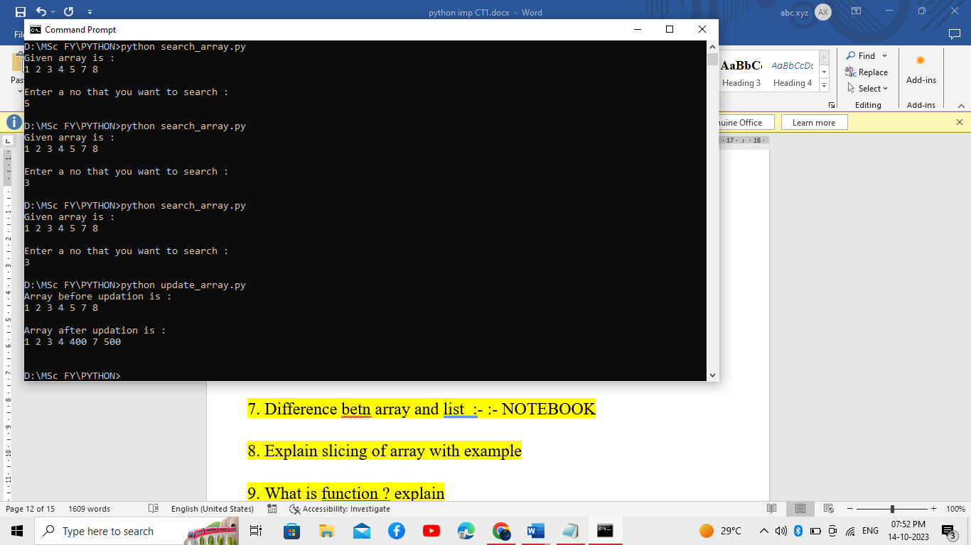for i in a:

print(i,end=" ")

print("\n")

1. Difference betn array and list :- :- NOTEBOOK
2. Explain slicing of array with example

* array **slicing** is a way to get a subarray of the given array.
* Multiple values stored within an array can be accessed simultaneously with array slicing. To pull out a section or slice of an array, the colon operator : is used when calling the index. The general form is:
* **Syntax: subarray =** <array>[start:stop]

import array as arr

a=arr.array("i",[1,2,3,4,5,7,8])

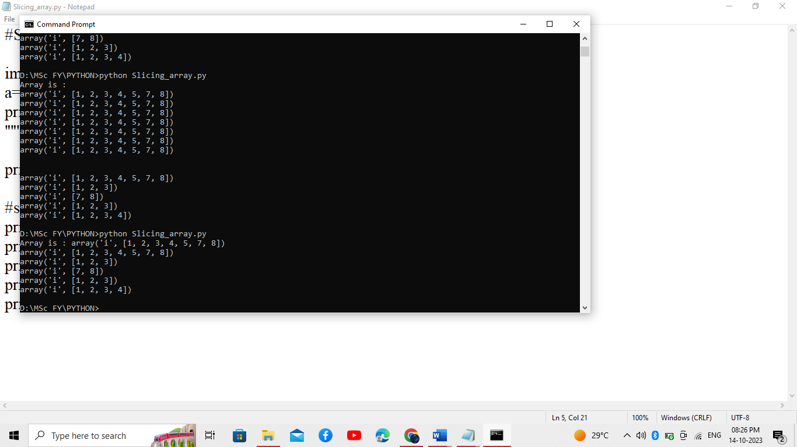print("Array is :",a)

#slicing

print(a[ : ])

print(a[ :3])

print(a[-2:])

print(a[0:3])

print(a[0:-3])

1. What is function ? explain

* A function is a block of code that performs a specific task. Functions can take arguments and return values
* To define a function in Python, you use the def keyword. The def keyword is followed by the function name and the function's arguments.
* The function body is then defined using indentation. For example, the following code defines a function called fact(), which takes a number as argument and returns the factorial of a number.

#Find factorial of number

def fact(n):

f=1

for i in range(1,n+1):

f=f*i

return f

n=int(input("Enter a number :"))

print("Factorial of ",n,"is : ",fact(n))

1. WAPP to implement stack using list

stk=[]

def push():

ele=int(input("ENter a no :"))

stk.append(ele)

print("element is inserted")

def pop_ele():

if not stk:

print("Stack is empty")

else:

e=stk.pop()

print("element is deleted")

while(True):

print("1.Push\n2.pop\n3.exit")

print("Enter your choice")

n=int(input())

if(n==1):

push()

elif(n==2):

pop_ele()

elif(n==3):

exit()

else:

print("Enter right choice")

1. WAPP to implement queue using list

que=[]

def enque():

ele=int(input("ENter a no :"))

que.append(ele)

print("element is inserted")

def deque_ele():

if not que:

print("Queue is empty")

else:

e=que.pop()

print("element is deleted")

while(True):

print("1.Enque(add element)\n2.deque(to delete element)\n3.exit")

print("Enter your choice")

n=int(input())

if(n==1):

enque()

elif(n==2):

deque_ele()

elif(n==3):

exit()

else:

print("Enter right choice")

1. WAPP to print given number is prime or not using function

#prime no

def prime(n):

f=0

for i in range(2,n):

if(n%i==0):

f=1

break

if(f==0):

print(n," is prime number")

else:

print(n," is not prime number")

n=int(input("Enter a number :"))

prime(n)

1. WAPP to find factorial of given number using function

def fact(n):

f=1

for i in range(1,n+1):

f=f*i

return f

n=int(input("Enter a number :"))

print("Factorial of ",n,"is : ",fact(n))

1. WAPP for array operations.

#array operation

import array as arr

#creating a array

a=arr.array("i",[1,2,3,4,5,6])

b=arr.array("i",[11,22,33,44,55,66])

print("Given Array is : ")

print("[",end=" ")

for i in a:

print(i,end=" ")

print("]\n")

#appending elements

a.append(56)

print(a)

#insert group of elements

a.extend([100,23])

print(a)

#inserting elements by position

a.insert(3,500)

print(a)

#remove last element

ele=a.pop()

print(a)

#slicing of array

print(a[0:4])

#updating element

a[3]=30

print(a)